**Setup minikube at local and explore creating namespaces**

Prerequisites to install:

1. Docker and Docker compose
2. Epel Repo
3. Minikube - readymade cluster for education purpose we cannot use this for production

Commands

**To install Docker and Docker compose**

yum install docker-io

sudo yum install docker-ce docker-ce-cli containerd.io docker-buildx-plugin docker-compose-plugin

sudo yum-config-manager --add-repo <https://download.docker.com/linux/centos/docker-ce.repo>

service docker start

minikube start --driver=docker

**To download the Epel repo and install**

Yum install wget

wget https://dl.fedoraproject.org/pub/epel/epel-release-latest-7.noarch.rpm

yum -y install epel-release-latest-7.noarch.rpm

chmod 744 epel-release-latest-7.noarch.rpm

sudo yum repolist

**To download Minikube and install**

curl -LO <https://storage.googleapis.com/minikube/releases/latest/minikube-linux-amd64>

sudo install minikube-linux-amd64 /usr/local/bin/minikube

minikube version

**To download and install the Kubernetes**

curl -LO https://storage.googleapis.com/kubernetes-release/release/`curl -s [https://storage.googleapis.com/kubernetes-release/release/stable.txt`/bin/linux/amd64/kubectl](https://storage.googleapis.com/kubernetes-release/release/stable.txt%60/bin/linux/amd64/kubectl)

yum install -y yum-utils

Commands:

**To create a POD in default namespace and list the pods**

minikube kubectl -- run nginx --image=nginx

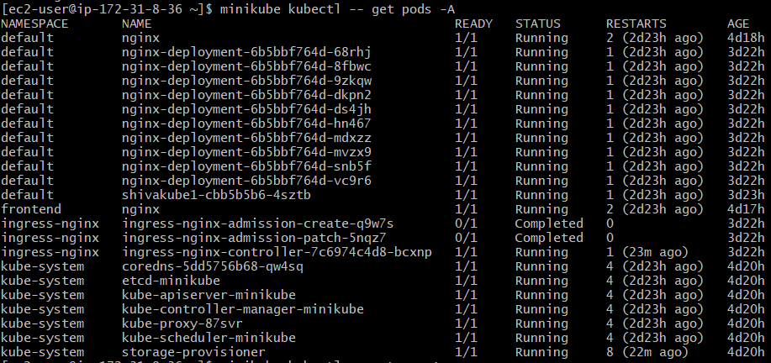

**To create a POD in a Namespace and list the namespace**

minikube kubectl -- run nginx --image=nginx -n frontend

